**Deputy Registrar Meeting Notes 4/28/2020**

Deputy registrars and DPS- DVS leadership covering the following information at a meeting Tuesday, April 21.

If we missed your topic/question, please send an email to dvs.communications@state.mn.us.

Notes from previous meetings are available on Info Hub under the [resources tab.](https://dvsinfohub.dps.mn.gov/resources/Pages/default.aspx)

**Highlights from DVS Director Corrie and A.C. Tim Lynaugh**

Since our Tuesday meeting the stay at home order has been extended until May 18.

We are encouraging deputy offices to outline specific social distancing and sanitizing plans they will have in place once operations are allowed to resume. Offices owned by the city or county should reach out and see what recommendations the city or county has started to put into place. Our communications dept. is working on a checklist of items you may want to consider as you develop your plans. We are not going to be directing what each office should do; you should take your recommendations from the CDC and Minnesota Department of Health guidelines to ensure safety of your staff and your visitors.

We had a meeting with Dept. of Labor and Industry this week, they shared some important information that we have added for you under the COVID-19 tab on resource center. We are working to see if department representatives can join a future Tuesday meeting to help address some of your office concerns once offices are allowed to open.

Members of our team are working on robust plans for return to work.

* Establishing guidelines for screening employees and visitors before entry into our facilities.
* Learning new ways to do business and adapting to the new normal.

In all adversity comes some level of opportunity. We are happy to share our plan with you as we move forward and a link will be added to resource center for you to view what we have in place for our staff and visitors to Exam Stations.

**Vehicle Services**

* Title and registration dept. has issued over 112,000 titles since Stay at Home order implemented.
* Work queues dramatically decrease.
* Most staff working remotely.
* Prorate staff working in office.
* Some staff has returned to work on tab renewal kick-outs.
* As they consider return to work plans, they will use a combination of remote work and in office while following social distancing.

**Driver Services**

* 41,000 apps left to process in our driver’s license queues.
* Working on cross training staff to process CDL drivers apps.
* Some staff return to office to get missing pages from applications scanned so that the processing can continue, as well as mail out returned cards for redelivery.
* Most staff working remotely.
* As they consider return to work plans, working on a remote work plan, DVS needs to determine how many staff may need to be in the office and social distancing.

**Support Services**

* 100 plus staff working remotely answers phones and emails.
* Since the stay at home order, have answered 200,000 plus calls remotely and responding to over 21,000 emails.
* Some staff have returned to office to begin imaging paperwork received by mail to keep work moving forward for customers.
* As they consider return to work plans, will work to reduce contact with others in person where possible, intermittent scheduling, installation of barriers and continuing to focus on telework when possible.

**MnDrive**

* Completed over 1,800 testing scenarios last few weeks.
* FAST team working on COVID-19 issues and SQRS that have been introduced.

**Record access/Fast ds**

There has been some confusion about whether or not deputy registrars are permitted to access Fast DS. Deputy registrars may access Fast DS to:

* Accept reinstatement fees.
* Accept disability applications (scan and attach to record).
* Accept medical certificates and self-certifications (scan and attach to record).
* Accept medical forms (scan and attach to record).
* Collect copies of documents to clear deficiencies.
* Check record if needed to complete a motor vehicle transaction.
* Process an application for disability parking certificate.

You may check a record in Fast DS to answer a customer’s question. However, make sure you are following data practices guidelines. If you are unsure whether the information the customer is asking for is public or private data, direct them to contact DVS.  
  
Resources:

* [DVS public contact information](https://dps.mn.gov/divisions/dvs/contact/Pages/default.aspx)
* DL status check, [drive.mn.gov](https://dps.mn.gov/divisions/dvs/online-self-services/Pages/default.aspx)
* [DVS Data Access quick reference guide](https://dvsinfohub.dps.mn.gov/Documents/QRG-DataPrivacy.pdf)

**VISION SCREENING**

* While vision screening and photos are being waived for seasonal CDLs at this time,CDL holders will be required to come into an office for a vision screen and have a photo taken once full driver license services resume.
* Once services resume, vision screening must take place on the vision test machines. We understand that customers may express concerns about using the vision machine. We will share what DVS exam stations will be doing once we reopen at our next meeting. In the meantime, the following information was included in the notes from the April 8 meeting:  
    
  To clean the vision machines:
  + Only use alcohol wipes to clean the headrest and the lenses to prevent damage.
  + You can purchase headrest tissues from Stereo Optical. Cost is $57 for 5,000 tissues; item number is 2000207.
  + To order: Visit the Stereo Optical website or Call 1-800-344-9500
  + You can use Clorox wipes or other spray cleaners to clean casing and mounting brackets. Do not use abrasive cleaners.

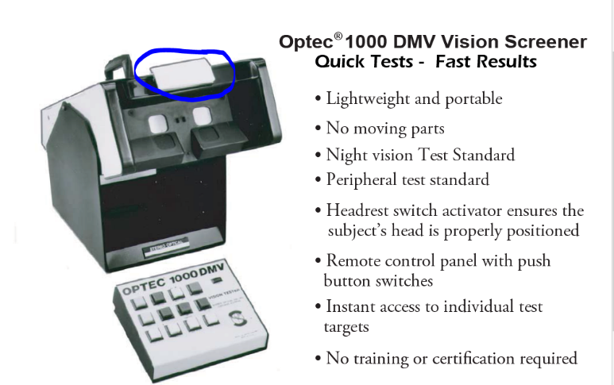

**Motor Vehicle Topics**

**Face-to-Face Transactions**

* At this time, deputy registrars are prohibited from providing face-to-face service, even if they have Plexiglas or something similar as a barrier between them and their customers.
* Customers may not enter your building location for service.
* You may accept drop-off transactions through a window provided your customer does not enter your building.

**Acceptable Forms of Payment**

Deputy offices are not required to accept checks as payment for services. We do ask that you communicate clearly to your customer and to us what payment types you will accept. If you want to change the payment types that your office accepts please reach out to us so that we can update the information available to customers on the website**.**

**Variance Requests**

Once the Stay at Home Order has been lifted, offices are expected to return to normal hours.

Offices have expressed interest in having a soft reopening, doing appointment only, or having reduced hours. As we move forward, any changes to hours will need to be submitted by variance for review.

The variance form is on [InfoHub](https://dvsinfohub.dps.mn.gov/Pages/deputy-reg-forms.aspx).

**Deputy Stock – Stickers and Plates**

If you need additional stock for your office, please reach out to [Lori Pearson](mailto:lori.pearson@state.mn.us) for assistance.

**DRIVER’S License Topics**

**Credential Processing**

* DVS is working on a possible procedure to allow customers to apply for a duplicate license if theirs has been lost or stolen. However, it is not yet available. These applications cannot be processed by a deputy registrar as they require face-toface interaction. The customer is required to sign the application. More information will be shared with you once the plan is finalized and approved.

**Credential Extensions**

* The extension applies to credentials that expire March 1 or later and ends two months after the month in which the peacetime emergency ends. We have updated the expiration date on the record of affected drivers.
* The communications dept. sent out a message through various channels including the MN Pharmacy board about the driver’s license extension. Customer’s licenses should be considered as valid under the peacetime emergency.

**Status Check Expirations**

* We are working on a procedure to assist drivers who documents have expired. We will communicate additional information as it becomes available.

**Clearing deficiency requests**

* Documents cannot be authenticated by email or fax. We must view the original document to verify the validity.

Unless an office can view the document and return it to the customer immediately while not being face to face with the customer you should direct the customer to contact the PIC for assistance.

If your office is not a scanning office, you should direct customers to PIC for assistance with clearing deficiencies.

* If an office chooses to take in a document by mail or drop box to clear a deficiency the office would be assuming responsibility for that original document, and we do not recommend offices do this.